Seminar Title: Using Library Facilities at CEAS Library

Speaker: Ted Baldwin, Director of the Science and Engineering Libraries

Venue: CEAS Library, University of Cincinnati, Baldwin Hall, Room 850
Time: 3:45 – 5:00 pm
Date: 15 June 2018

Prepared by:
Jennifer Leigh Myka, Gateway Community & Technical College, Florence, Kentucky
RET Participant for Project #1: “Membrane Bioreactor System for Wastewater Recycling and Recovery of Phosphorus from Wastewater”

This session was given by Mr. Ted Baldwin, Director of the Science and Engineering Libraries since 2012. Previously, he was department head for the College of Engineering and Applied Science (CEAS) Library. He oversees services and staff at CEAS Library, and is responsible for purchasing journals and databases. He has also worked in industry, managing the Research & Development Library at Lyondell Chemical Company. Mr. Baldwin has a Master’s degree in Library Science from Indiana University (with a Specialist’s Certificate in Chemical Information), and a BA from DePauw University, with majors in Music and Chemistry.
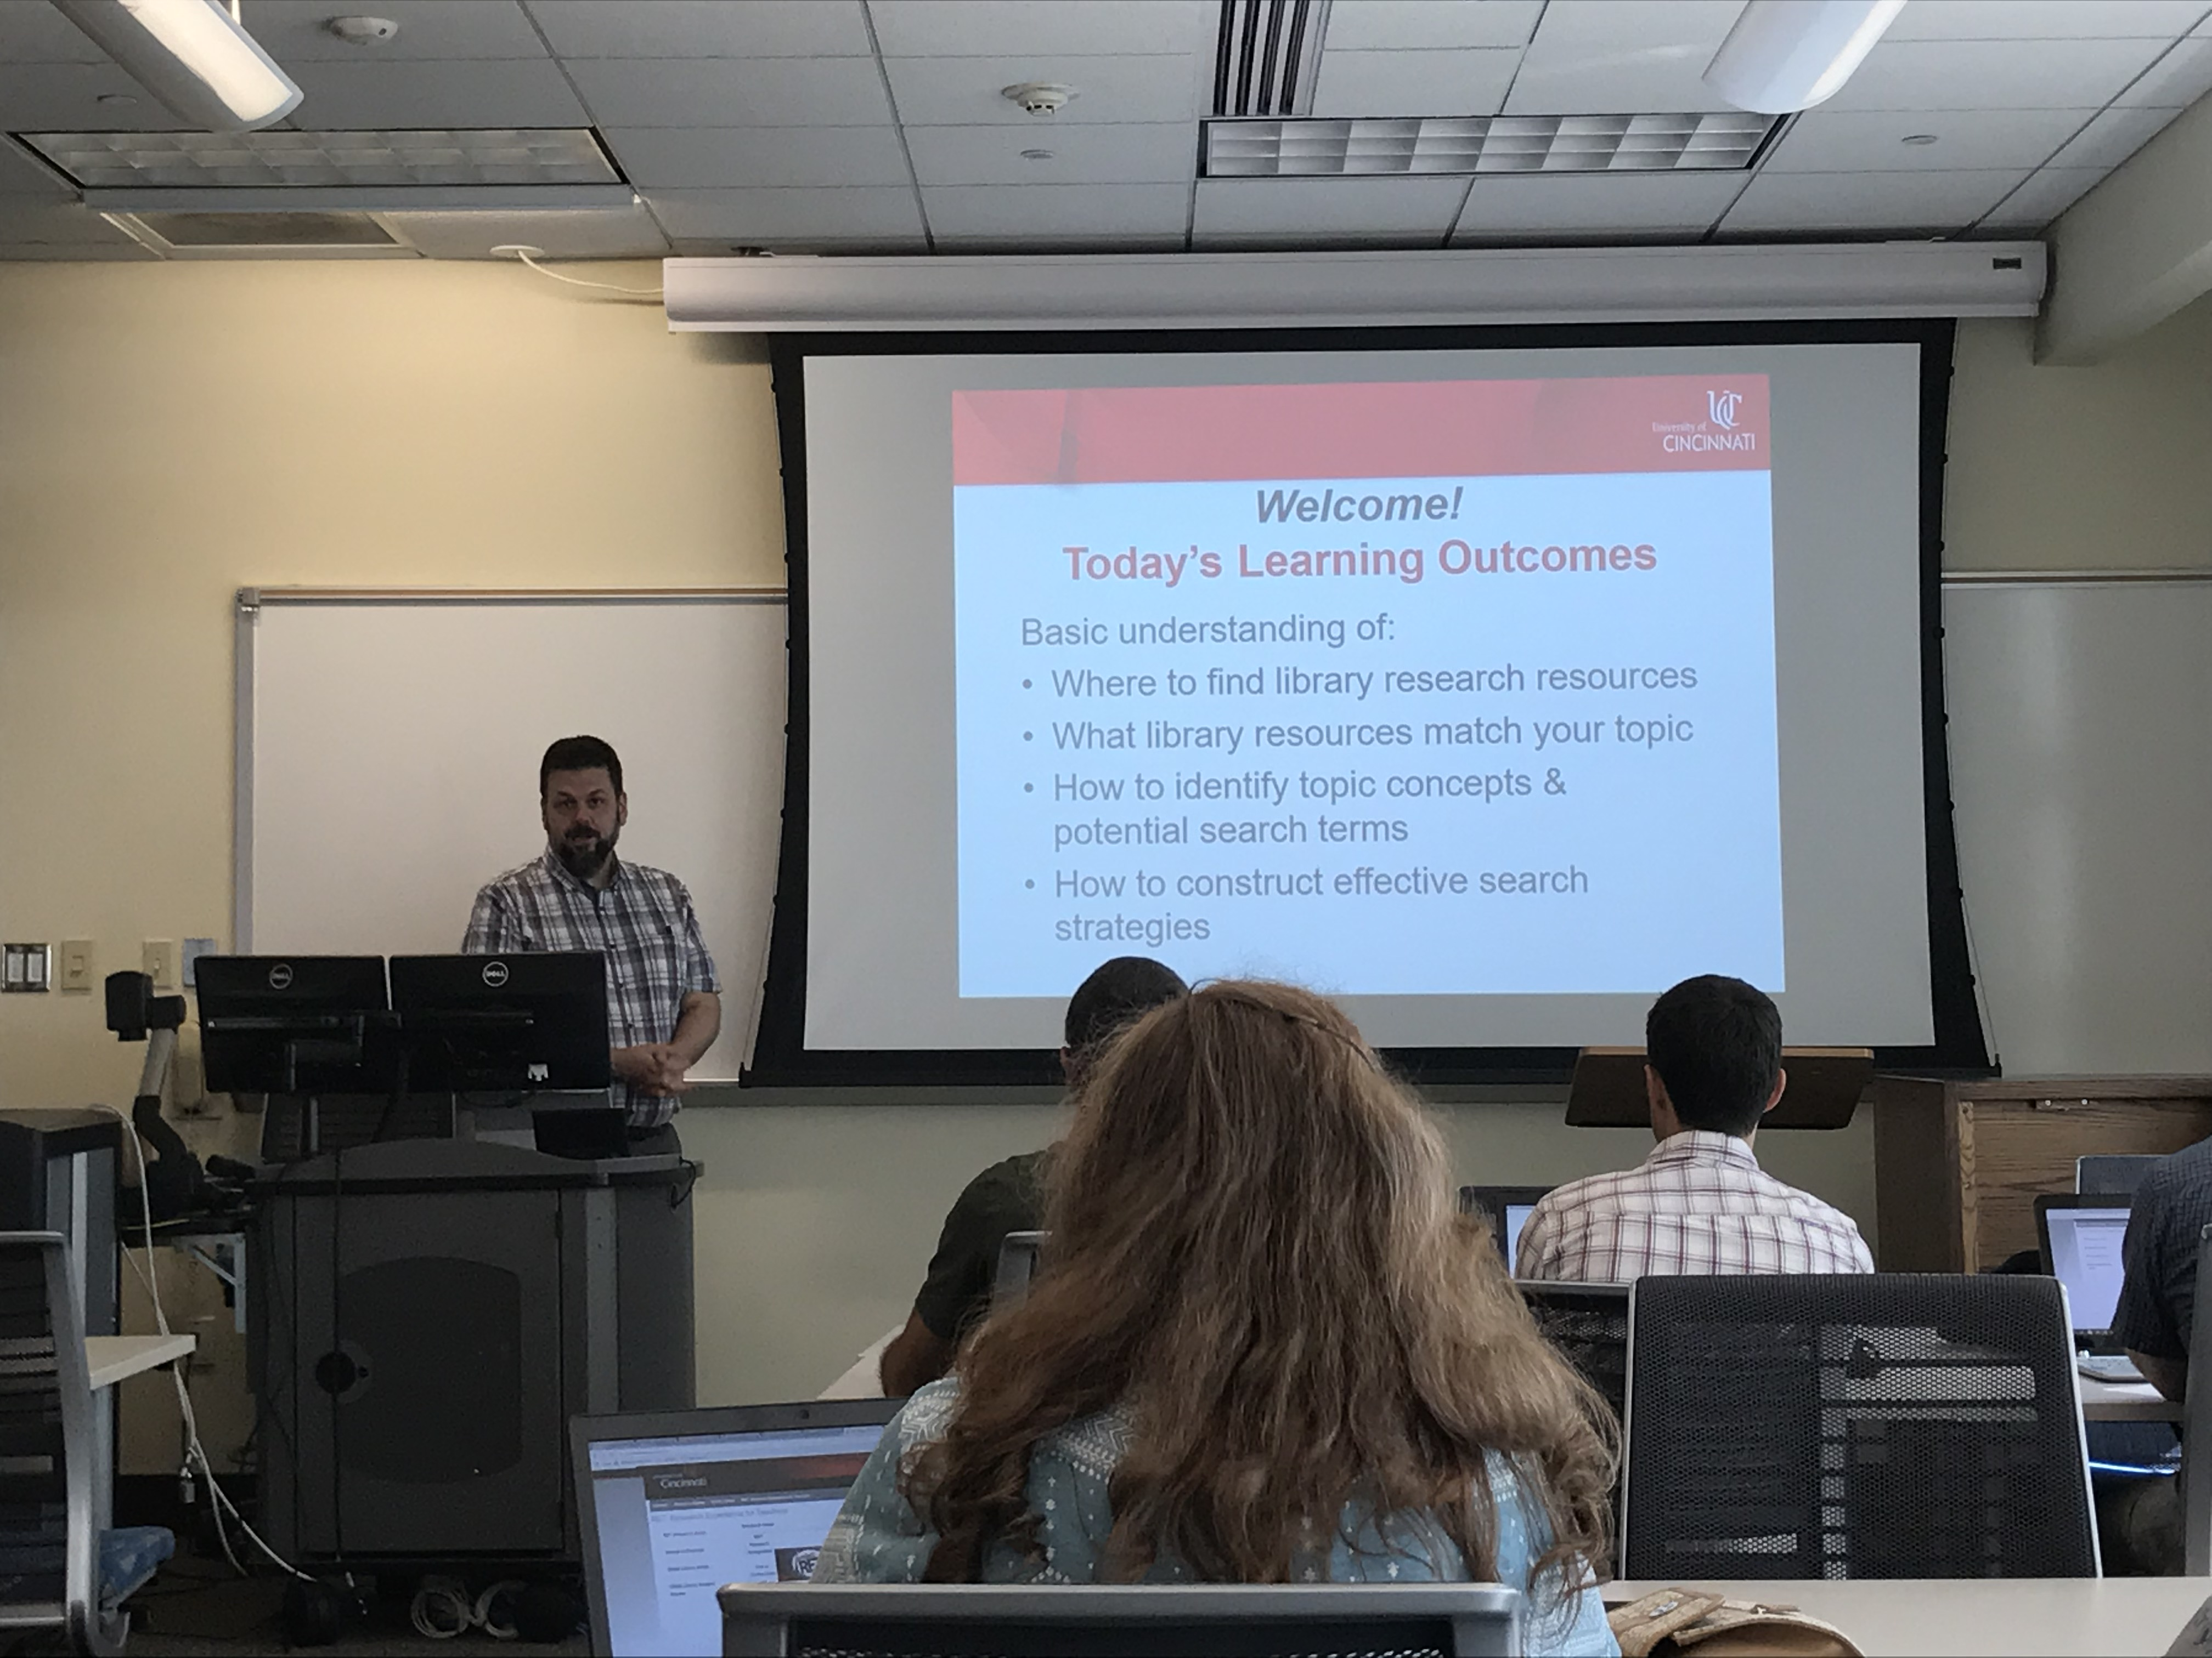
Figure 1: Learning Objectives for Seminar

As shown in Figure 1, Mr. Baldwin opened his session with the learning outcomes for the seminar: where to find library research resources, what library resources match your topic, how to identify concepts and potential search terms, and how to construct effective search strategies. He explained that this seminar used a different approach to library research by focusing on the strategies to get what is needed from the databases. The analogy he shared was that finding research resources is like a finding a shovel in a haystack or a person in an apartment building. The idea is to start with determining where to start, what resources should be used, and determining where to find the needed resources.

The first segment of the seminar consisted of asking questions such as the following: What are the key concepts or the scope of the topic of research? Are there human or animal research subjects? What time frame should the research focus on? Is this historical or new research? These questions, if applied appropriately, should lead to a database search that finds 100-200 relevant articles.

Next, Mr. Baldwin highlighted the approach by using a specific sample topic (refer to Figure 2). In step one, gut microbiome and obesity were chosen as the topic of the research. In step two, predicting obesity in children was established as the aspect of the topic most relevant to the research. In step three, the topic was stated as a question: “Can the gut microbiome in children predict their risk of obesity?” Given this research question, Mr. Baldwin showed the group how to break the question into three concepts, gut microbiome, obesity, and children. For each of the three concepts, he suggested recording as many terms or keywords that were synonymous with these terms or phrases. One strategy of obtaining additional keywords was to do an online search for the terms separately and see which alternatives might also be used in the technical and/or scientific literature.

Figure 2: Steps to Approaching a Research Topic | Figure 3: Combining Boolean Operator

After a short list of alternatives was determined for each main concept, Mr. Baldwin explained how to “translate” these keywords into Boolean search language for the databases. In essence, he explained how to handle phrases and the Boolean “AND” and “OR” terms to construct a search strategy or search statement. As seen in Figure 3, Mr. Baldwin illustrated visually how Boolean operators can be used to find the most relevant information. Multi-word terms must be delineated with quote marks in order for the databases to recognize them as needing to stay together as phrases. Within parentheses, Mr. Baldwin suggested using the Boolean operator “OR” so that the database will identify articles with all of the alternative terms or phrases, rather than requiring articles to contain all of them. Between parentheses, Mr. Baldwin suggested using the Boolean operator “AND” so that the database will find articles with any version of each of the desired search terms but still contain all desired concepts. Mr. Baldwin explained that this process should be modified as necessary to get to the goal of a reasonable number of relevant research articles. He explained that adding “OR” will expand the results while “AND” applies limits to narrow the matching articles. He mentioned that it can be helpful to look at how relevant citations were indexed and consider adding terms. He said this process works best if the researcher continues to assess, modify, and recombine terms as needed to obtain satisfactory results. Figure 4 shows one search strategy using the research question “Can the gut microbiome in children predict their risk of obesity?” that might be used to find appropriate research articles.
(“gut microbiome” OR “GI microbiome”) AND (obesity OR overweight) AND (child OR pediatric)
Figure 4: Example of an Effective Search Strategy

Once the search statement is constructed, be sure to make the statement as broad as possible to begin with to allow later narrowing. If too many results are obtained, identify relevant literature databases. Mr. Baldwin suggested trying the search and then adjust as needed, and that searching a few different databases is often a helpful strategy. He also mentioned that if a good article is found, use the ”related articles” link provided by the database and also look at the bibliography or citations list provided by the authors to find additional relevant literature.

Mr. Baldwin then provided an overview of several different databases that can be accessed through the University of Cincinnati (UC). He demonstrated how to access full text journals through various means including the UC Article Linker button and mentioned that UC has about 1,000 titles available as full-text. He explained that each database provides different types of information. For example, Knovel can be used to find data tables and graphs in addition to more traditional journal articles. Through the CEAS Library Website, the card catalog, e-book, and conference proceedings collections can be accessed, including options for interlibrary loan of items throughout Ohio using the OhioLINK catalog. Google Scholar can be used as a point of reference. Mr. Baldwin noted that Google Scholar uses “|” instead of “OR” in the search term syntax. He also pointed to Scopus and Compendex as databases with similar information but Scopus has a collection that is more broad while Compendex is much more engineering focused.

Figure 5: Clarifying the Search Strategy One-On-One

Finally, Mr. Baldwin separated everyone into their research groups and gave each group a specific topic to use to build a relevant search strategy. The specific topic was included on a Group Activity Handout and included guidelines to create a search strategy based on the steps he illustrated earlier. He walked around the room and facilitated the work of each group as can be seen in Figure 5. He mentioned that Google or Wikipedia can be used early in the process simply to help identify additional terms to use to search. He also noted that a search strategy can be broadened when an asterisk is used to expand search terms like toxic* to include toxic and toxicity or efficien* to get efficient and efficiency, etc. Each group completed the exercise by taking the provided topic, determining the concepts included, choosing search terms based on the concepts, constructing a Boolean search strategy, and finally testing the strategy in Scopus and/or Compendex.

At the end, Mr. Baldwin showed how additional filters can be used to sort the results by date or numbers of citations or lists of important authors, and he indicated several controls that can help either narrow or broaden a search once relevant articles are identified. In conclusion, the entire group was successful in constructing an effective Boolean search strategy with results in the general range of 100-200 relevant results. Several participants later noted that the new approach that Mr. Baldwin used for this seminar was highly effective and that all learned new information and new skills that will be very useful for RET and beyond.

